**GCR Basic HU Installation Guide**

Contents

**A.** **Included Apps** 2

**B.** **Installation Requirements** 2

**C.** **Preparing the USB** 2

**D.** **Setting up Android Auto on Android Phone.** 3

**E.** **Installing the apps on GCR** 3

**F.** **Setting up Back Button Anywhere** 4

**G.** **Setting up Button Remapper** 4

**H.** **Setting up Android Auto on HU** 5

**I.** **Setting up Autokit for carplay, requires carlinkit dongle** 6

**J.** **Installing Apk Manually** 7

**K.** **Uninstalling Apps Manually** 7

**L.** **Factory Reset** 7

# **Included Apps**

1. Android Auto (AA) – allows Android Auto interface to HU
2. Autokit – allows iPhone carplay interface to HU. Requires Carlinkit dongle. Most prefers wireless. <https://s.lazada.com.ph/s.6QBGx>
3. Backbutton – creates a backbutton shortcut. Allows access to car’s android settings
4. ES File Explorer (ES) – allows file system navigation. Should ONLY be used to access USB.
5. KeyRemap (Button Remapper) – allows steering wheel button assignment to control apps like Spotify and AA.
6. Netflix – Requires Netflix acct. Note: Cannot control progress button as it prompts GCR control bar at the bottom (AC control). Else, rooting required.
7. SmarTube – Alternative YouTube
8. Spotify – requires Spotify acct
9. Wifi Manager – allows connection to wifi or hotspot
10. CarLauncherPro – a car theme-based app. needs to be installed manually. See steps for manual installation.

# **Installation Requirements**

* 4-32GB USB (FAT32 format) – used usb is OK, no need to delete/reformat
* Computer – not needed in the car
* Wifi or Hotspot to connect car to internet

# **Preparing the USB**

1. Check if your USB is FAT32 format. On your computer, insert USB and rightclick on the USB drive. Proceed if it’s FAT32.

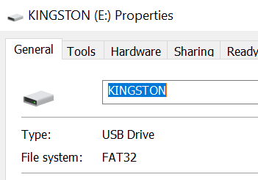

1. Download the file ([Gdrive link](https://drive.google.com/file/d/1RD0hyn92UuL_jRQq3G4NODY0eJobI3jB/view?usp=share_link)).
2. Extract/unzip the file, open GCR Basic folder, select all 3 files then copy to root USB as below.

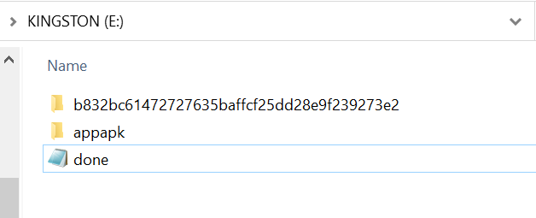

# **Setting up Android Auto on Android Phone.**

Optional apps for Android Phones in InstallToPhone folder

* AAforPhoneScreen – if installed on your phone, this creates an icon on your phone so you don’t have to go to Settings to search and open AA app.
* aastore – allows you to download and install 3rd party AA apps. Carstream (YT in AA), Screen2Auto or AAMirror+ (screen mirroring), FermataAuto (onlineChannels, etc).

1. Open AA on phone.
2. Customize launcher – choose the apps you want to appear in the car screen launcher.
3. Hey Google detection – this is for handsfree voice commands. Yes, it can also control all VC on your phone including your smart devices. Enable it then add/train voice model.
4. Day/Night – set to phone-controlled. Renders the maps based on time of the day
5. If you want to see if your phone is stable for wireless AA connection, enable Dev Settings.
6. Tap “Version” (bottom) until pop up appears then click OK.
   1. Click on 3 dots upper-right. You should see Developer Settings and Start Headunit.
   2. If you install 3rd party apps, go to Dev Settings and enable Unknown Sources.

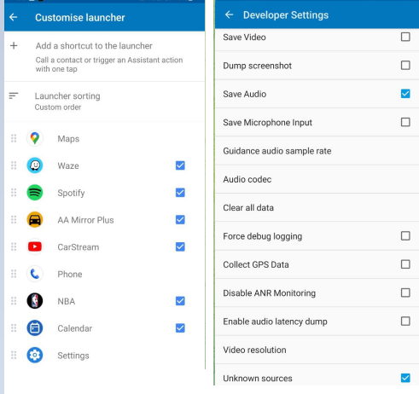

# **Installing the apps on GCR**

1. Start your car. Pause the radio and press home button (Geely logo in HU or Steering Wheel)
2. Insert the USB on passenger side USB port.
3. Press Cancel when popup window appears. If no popup, your USB cannot be read.
4. Allow the 9 apps to install until HU reboots.

# **Setting up Back Button Anywhere**

1. Open BackButton app. Scroll down then click Go to Settings
2. In Android settings, click Back Button Anywhere then enable (upper-right toggle). You should see a small backbutton icon on the right of your screen.
3. On the BackButton App, click Long press action. Select Launch Settings.

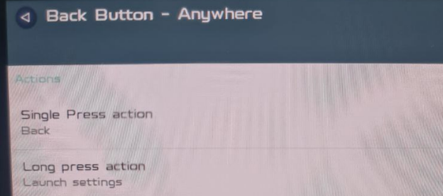

1. If you want to customize the small backbutton icon, you may change the button and background colors and size. To hide, change both colors to 100% transparent.
2. Lock the button position so the small icon won’t move.

Note: Clicking the small backbutton will now be your "back or exit button". long press or holding it will bring you to Android Settings.

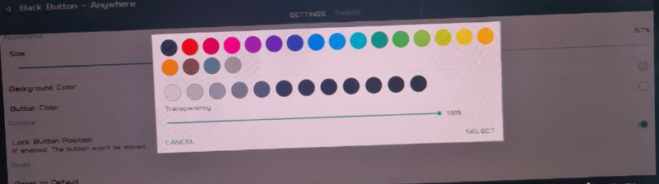

# **Setting up Button Remapper**

1. Open Button Remapper then toggle System Enable. It will open Android Settings.
2. Enable Button Remapper (like you did for back button). If it does not show, click the small backbutton once.
3. Once back in Button Remapper app, click yellow + at lower right. Then select short/long press.
4. Select Key then Other, click the button on steering wheel you want to assign. (eg. Previous track button [Left Arrow button on right steering wheel]=STEMPRIMARY)
5. Under Action, replace “Recent Apps” with the task you want to assign. (eg. Previous track) Note: scroll down slowly.
6. Uncheck Block System Action then Save.

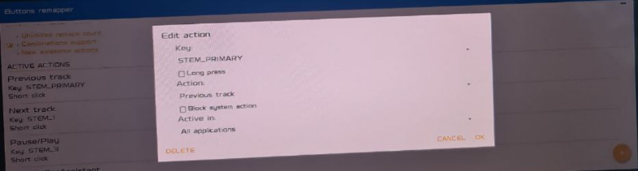

1. Repeat from step 3 for other key/action combinations.
   * Next Track button (STEM1/Next track)
   * Bury the volume rocker (STEM3/Play-Pause)
   * Empty button, left of steering wheel (WAKEUP/ under Action, select Other > Open App. Then choose the app you want to open. eg. 360Panorama.

# **Setting up Android Auto on HU**

1. Open AA in HU, swipe to right 3x.

2. Select highest resolution. for mid range phone, try the 2nd resolution first.

3. Click Test then YES or OK regardless if the pic did not load. Then click DONE.

**Wired connection: Stable for most android phones**

* Insert data cable (not charging only) to your android phone and to driverside usb port.
* On first connection, tick make default checkbox when popup window appears (this will popup 2x).
* There will be onscreen message on your phone and HU. just click next and continue.
* AA interface should load

Note: if you used QDLink before, you might need to clear data/defaults on your phone and HU. To clear on HU, hold small backbutton to go to android settings, click Storage > Apps (green) then go to ALL tab and look for **QDLink**. Scrolldown a bit and you should see Clear Data and Clear Defaults button.

For most phones, you only need to plug the cable and AA will load automatically after the first setup. For other phones, you would still need to open AA on HU, click the big usb logo then select your phone in the 2 choices.

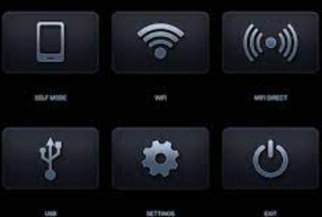

**Wireless connection: Note: stable only for highend phones.**

* Enable hotspot on your android phone and connect your HU to your hotspot via Wifi Manager.
* Open AA on phone, click 3 dots then click on Start headunit server.
* Open AA on HU then click on big wifi logo. AA interface should load.

# **Setting up Autokit for carplay, requires carlinkit dongle**

1. Connect HU to wifi via Wifi Manager.
2. Open Autokit app. Set as default if prompted.
3. Allow version upgrade via wifi if prompted.
4. Make sure siri is enabled on your iphone.
5. Insert carlinkit dongle on driverside USB port.
6. If your carlinkit is wireless, there should be signal under Wifi/BT icons on the upper-left like Autokit-1234. if none, your carlinkit is for wired only. Note: wired connection will also work for wireless autokit.
7. For wired connection, it's plug and play. Just insert your lightning cable to the back of carlinkit dongle. Carplay should load.
8. For wireless, turn off your car's Bluetooth(BT) first.
9. On your iphone, connect BT to the Autokit-1234 signal. connection will automatically move to wifi then carplay should load. All Siri commands should work in carplay too.

Note: Pls make a call from carplay without reconnecting the car's BT and see if call audio will be on car or phone. if not on car, you may need to reconnect your phone to the car's BT.

1. Go to advanced settings > Key Learning (Beta)
2. Click on button you want to assign (eg. Previous track, Next track), it will ask you to click the desired button on your steering wheel then on HU screen again.

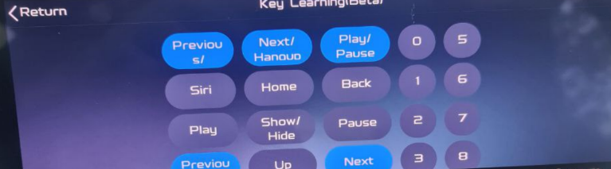

# **Installing Apk Manually**

Note: GCR OS is Android 4.3 only so you can only install apps that are compatible to 4.3 version.

1. Download the app apk and copy to USB then insert on passenger side port. You can use CarLauncherPro under ExtraAPK folder as example.
2. Open ES File Explorer > Local > Udisk2 to access your USB
3. Click on the apk file you want to install. On first manual install, you will be prompted to go to android settings, then allow unknown sources.

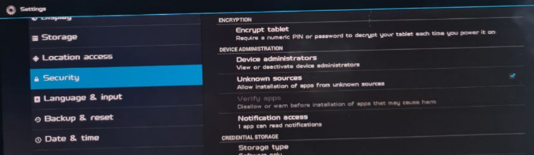

1. Go back to ES Explorer then click the app you want to install.
2. Click Install >> Next >> Install

# **Uninstalling Apps Manually**

1. Hold the small back button to go to Android Settings
2. Click on Storage > Apps (Green). Then under DOWNLOADED tab, select the app you want to delete.
3. Click uninstall to proceed.

Note: Follow same steps to kill an app or clear data or clear defaults of an app. (ie. App unresponsive)

# **Factory Reset**

Note: This installation is fully resettable. All installed apps can be deleted and your HU will be back to stock.

1. Open Settings app (Gray Gear Icon)
2. Go to System > Restore to factory settings.
3. HU will reboot then all side loaded apps should have been removed.